KENDRIYA VIDYALAYA NO.2,SALT LAKE
PRIMARY SECTION
HOLIDAY HOME WORK FOR SUMMER VACATION
(09/05/2022 To 17/06/2022)
NOTE—MAKE A SEPARATE COPY FOR HOLIDAY HOMEWORK
CLASS-III
ENGLISH
1 Do 20 pages Handwriting from your textbook.
2 Read at least 5 story books and keep a record of it along with books’ name and author’s name.
3 Make a MDP (project) on your chosen topic with Art integration.
4 Write 5 lines on ‘A visit to a garden. ‘
5 Make a list of different birds you see around you.
6 Make sentences with the following words:
Magic, Pretty, Playground, Bird, Funny
7Pick out the rhymingwords from the poem ‘Bird Talk’.
8Draw a garden and colour it.
9 Make a stick paper bird.
10 Write articles for class magazine
11. Make Dolls and Toys with waste materials.

CONT……………

HINDI
1)प्रतिदिन ४ पेज का पठन करे।
2)१०पेज सुलेख लिखे।
3)स्वरचित कविता या कहानी लिखे।
4)10 मुहावरेऔर10 कहावतें उनके अर्थ के साथ लिखे।
5)पर्यावरण संरक्षण के बारे में वाक्य लिखे और इससे सम्बन्धित कोई चित्र बनाओ।
6)कोई एक कहानी पढ़े और निम्नलिखित जानकारियां लिखे-
अ लेखक का नाम
ब कहानी के पात्र
स कहानीका सारांश
7)प्रतिदिन अखबार पढ़े और महत्वपूर्ण सूचनाओं को लिखें।
8)"व्यक्तिगतस्वच्छता"विषय पर एक निबन्ध लिखो।
9)कक्षापत्रिका(ClassMagzine)केलिएचित्र, चुटकुले या कोई रोचक कहानी तैयार कर सकते है।
10)दस शब्द लिखकर उनके पर्यायवाची शब्द लिखें|
11)अपने मन पसंद दो पशुओं और पक्षियों के बारे मे लिखें|(चित्रभीबनाइये)
12)Make Dolls and Toys with waste materials.
13)Make a MDP( project) on your chosen topic with Art integration.

MATHS
1.Learn table from 2 to 10. Write numbers in words from 2 to 50.
2.Draw 5 objects from top view and 5 objects from side view.
3.Make the model of a clock and table.
4.Write in hundreds, tens, and ones-
( ₹156, ₹220, ₹273, ₹197, ₹704, ₹999, ₹300, ₹444)
5. Make five 2-D shapes and paste them on a sheet.
6.Write skip counting from 1 to 50.( Skip numbers are 2, 3, 5, 6, 7, 9, 10,11, 12)
7.Use measuring tape and measure-
A)Your height
B)Hand
C)Around the wrist
D)Around the hand
8.Read about 2 Indian mathematicians and write on A-4 size sheet. Paste the pictures also.
9. Make two word problems based on real situation.
10.Make a flash card for even and odd number up to 100.
11.Make a MDP (project) on your chosen topic with Art integration.
12.Write articles for class magazine
13. Make Dolls and Toys with waste materials
EVS
1.Draw your own family tree in one fourth size chart paper.
2. Observe any 5 animals in your surrounding (ants, lizard, bee, dog, birds etc.) and draw them in
one fourth size chart paper.
3. Make a poster on “SAVE WATER” and write 5 ways by which we can save water in one
fourth size chart paper.
4. Draw any 3 parts of a house (kitchen, bedroom, dining room) and colour them. Label each
thing in the picture in one fourth size chart paper.
5. Collect 5 different types of leaves. Let them dry by covering them with newspaper and paste it
in one fourth size chart paper and write their name also.
6. Draw any five pictures of fruits and five pictures of vegetablescolour them. Label each thing
in the picture in one fourth size chart paper.
7.Draw or paste the pictures of some healthy food items in one fourth size chart paper, write
their names and colour them.
8. Draw or paste the pictures of some indoor games in one fourth size chart paper, write their
names and colour them.
9. Make a model of any type of house using materials available at your home.
10. Name the different food habits of different ten states of our country in one
fourth size chart paper.
11.Make a MDP (project) on your chosen topic with Art integration.
12.Write articles for class magazine
13. Make Dolls and Toys with waste materials

CONT……….

CLASS-IV
ENGLISH
1.Do one page handwriting from your textbook daily.
2.Read at least five story book and keep a record of it along with book names and authors’ name.
3.Do story review of the story " Neha's Alarm clock" and include all these details
a)Book Name -b) Author Name-c) Characters-d) Summary-
4 Make a book mark for your ENGLISH BOOK.
5.Do any one in A4 page. ( For School Magazine / Class Magazine)
a. A self-composed storyb.Self written poem. c. Quiz d. Jokes
e. Science articles. f) Drawing / Painting
6.Make MDP Project for the following topics : ( Write articles and poems)
a) Water( Roll:1-10) b) Foods( Roll: 11-20). c) Animals ( Roll: 21-30)
d) Trees ( Roll: 31-40 ) e ) Transport ( Roll-41 - rest of the students )
7. Underline the new words from the story THE LITTLE FIR TREE and poem RUN in your book.
8. Make a list of 10 similar sound words (Homophones).
9.Write 8-10 sentences about How you have spent your summer vacations.
10.Write articles for class magazine
11. Make Dolls and Toys with waste materials

CONT……………………

HINDI

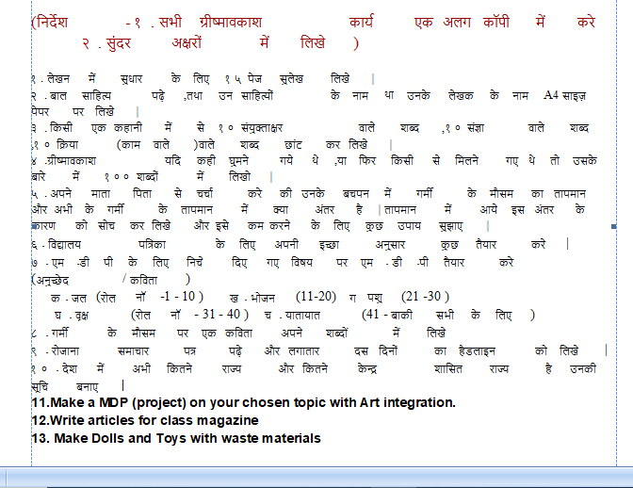

CONT…………………….

CLASS-V
ENGLISH
1) Prepare a dictionary of your class 5 English text book. Write all difficult words and its meaning lesson wise in a separate notebook in the form of dictionary.
2) Read newspaper every day. Learn and write difficult words with their meaning.
3) Write an article on “Covid-19 – Effect On Student Life”
4) Make a story board of coming chapters. ( Make for any one chapter)
5) Write self-written poem/story/article/paragraph etc. for class and school magazine.
6) Write 10 pages English calligraphy/handwriting.
7) Find 20 describing words and write their other two forms.
8) Make any useful item from waste materials to decorate your house and write its step in H.H.W notebook.
9) Write a paragraph on “ If I become the head of my family”.
10) Prepare yourself for “Periodic Test – 01(July)”.
11.Make a MDP (project) on your chosen topic with Art integration.
12.Write articles for class magazine
13. Make Dolls and Toys with waste materials

NOTE:
1) Do all H.H.W written work in a separate small notebook.
2) Take proper care of your health. Keep doing yoga and physical activities and drink lots of water to stay healthy.
3) Stay safe, stay healthy and enjoy your summer vacation.
HINDI
1)प्रतिदिन ४ पेज का पठन करे।
2)१० पेज सुलेख लिखे।
3)स्वरचित कविता या कहानी लिखे।
4)10 मुहावरेऔर10 कहावतें उनके अर्थ के साथ लिखे।
5)पर्यावरणसंरक्षण के बारे में वाक्य लिखे और इससे सम्बन्धित कोई चित्र बनाओ।
6)कोई एक कहानी पढ़े और निम्नलिखित जानकारियां लिखे-
अ)लेखककानाम-
ब)कहानीकेपात्र-
स)कहानीकासारांश-
7)प्रतिदिन अखबार पढ़े और महत्वपूर्ण सूचनाओं को लिखें।
8)"कोरोनासेबचाव" पर एक निबंधलिखे I
9)कक्षापत्रिका(ClassMagzine) केलिएचित्र,चुटकुले या कोई रोचक कहानी तैयार कर सकतेहै।
10)दस शब्द पाठ३ खिलौनेवाला या पाठ ४ नन्हाफनकार से लिखकर उनके पर्यायवाची शब्द लिखें|
11)अपने मनपसंद दो कवियों या लोककथा या सुभद्राकुमारी चौहान पर निबंध लिखें|
12) Write an article for class magazine. (A4 size paper)
13)Make a MDP (project) on your chosen topic with Art integration.
14)Make Dolls and Toys with waste materials
MATHS
- Draw the angle of given measurement by using protractor:-
- 75° b) 135° c) 45° d)90° e)120°
- Write the type of angle :- (acute, right , obtuse)
- 40° b) 90° c) 75° d)125° e)145°
- Draw the hands of clock when they make an angle which is less than a right angle.
- Find the perimeter of the following things :-
- Table b) Study room c) Door d)bed e)Mobile
5) Make a quiz of 10 questions based on maths on A4 size paper.
6) Solve different kinds of puzzles related to mental Maths.
7) Prepare a chart of magic squares and Sudoku.
8) Prepare your MDP Project for Maths on the given topics :-
a) Water (Roll no.-1 to 9) b) Air (Roll no.-10 to 18)
c) Forest (Roll no.- 19 to 27) d) Travel (Roll no.-28 to 36)
e) Food (Roll no.-37 to 44)
9) Write an article for class magazine. (A4 size paper)
10) Write 10 lines about any Indian mathematician. (A4 size paper)

CONT………………….

